Spiritual, Moral, Social and Cultural Development policy

Brighton Hill Community School

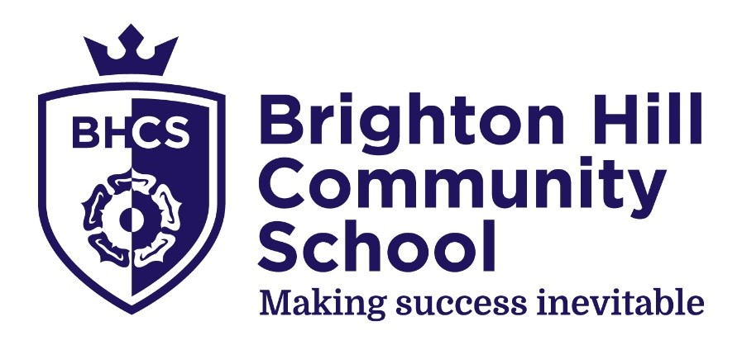

Approved by: Governors |  |  | Date: September 2025
Last reviewed on: September 2025
Next review due by: September 2027

Contents
1. Principles 2
2. Practice 2
3. Monitoring and implementation 2

1. Principles
We use the following definitions of Spiritual, Moral, Social and Cultural:
Spiritual
- ability to be reflective about their own beliefs (religious or otherwise) and perspective on life
- knowledge of, and respect for, different people’s faiths, feelings and values
- sense of enjoyment and fascination in learning about themselves, others and the world around them
- use of imagination and creativity in their learning
- willingness to reflect on their experiences.
Moral
- ability to recognise the difference between right and wrong and to readily apply this understanding in their own lives, recognise legal boundaries and, in so doing, respect the civil and criminal law of England.
- understanding of the consequences of their behaviour and actions
- interest in investigating and offering reasoned views about moral and ethical issues and ability to understand and appreciate the viewpoints of others on these issues.
Social
- use of a range of social skills in different contexts, for example working and socialising with other pupils, including those from different religious, ethnic and socio-economic backgrounds
- willingness to participate in a variety of communities and social settings, including by volunteering, cooperating well with others and being able to resolve conflicts effectively
- acceptance and engagement with the fundamental British values of democracy, the rule of law, individual liberty and mutual respect and tolerance of those with different faiths and beliefs; they develop and demonstrate skills and attitudes that will allow them to participate fully in and contribute positively to life in modern Britain.

Cultural
- understanding and appreciation of the wide range of cultural influences that have shaped their own heritage and that of others
- understanding and appreciation of the range of different cultures in the school and further afield as an essential element of their preparation for life in modern Britain
- ability to recognise, and value, the things we share in common across
- cultural, religious, ethnic and socio-economic communities
- knowledge of Britain’s democratic parliamentary system and its central role in shaping our history and values, and in continuing to develop Britain
- willingness to participate in and respond positively to artistic, musical, sporting and cultural opportunities
- interest in exploring, improving understanding of and showing respect for different faiths and cultural diversity and the extent to which they understand, accept and respect diversity. This is shown by their respect and attitudes towards different religious, ethnic and socio-economic groups in the local, national and global communities

The 4 aspects of SMSC above align closely with our 4 school cornerstones of:
- Kindness
- Courage
- Commitment
- Collaboration
and are reflected in our school’s vision statement as follows:
At Brighton Hill Community School, we are committed to building an environment where success is inevitable. We will achieve this by ensuring that:
- Students are proud to belong to a school in which they feel happy, safe and empowered to reach the next stage of their personal learning journey.
- All staff are committed to relentless continuous improvement, delivering the very best education for our students.
- We embrace collaborative opportunities, both internally and externally, knowing that this engagement will offer challenge and support.
- Students will develop aspirations and be able to make informed career decisions which will change their lives for the better.

2. Practice
Belonging is at the heart of the school’s culture and the 4 strands of SMSC permeate throughout all aspects of school life. It would be impossible to list all elements of the school’s practice with regard to SMSC, but the points below serve to illustrate some of our key practices which embed SMSC into school life.
All aspects of SMSC are incorporated, along with PSHE (including RSE), Citizenship, Prevent, British Values and Key Stage 4 RS statutory requirements, into the Brighton Hill Community School Values strands which are referenced in all subject-specific schemes of learning and, where applicable, all aspects of the tutor programme which include:
- weekly year group assemblies with a planned schedule which can be adapted to reflect topical and current issues
- weekly topical personal development sessions
- house assemblies which promote belonging and celebrate achievements and behaviour
- at least bi-annual whole school assemblies which promote belonging and celebrate achievements and behaviour
- the My World curriculum which is taught in 2 30-minute sessions per week and assessed half-termly. The My World curriculum is a key vehicle for the delivery of SMSC and is spiral by nature, revisiting and building on key strands which have been previously covered to ensure long-term retention of the key learning points. This curriculum is adapted as and when necessary to respond to current topical issues, both local and national. Sessions are tailored appropriately for students’ needs, including students with SEND, at the point of delivery by the teacher or tutor.
A termly audit of the coverage of Values strands in subject and tutor curricula is undertaken to ensure the broadest possible coverage across all aspects of the curriculum.
Religious Studies, which naturally has a heavy focus on the SMSC strands, is taught as a core subject from Year 7 all the way through to Year 11 using the approved Hampshire syllabus for RE (Living Difference IV). The Humanities Faculty and Key Stage 4 Core RS Lead work together to ensure a coherent, well-sequenced and balanced curriculum which features depth studies of religions as well as philosophical and moral topics which draw on the viewpoints of multiple religions to help students gain a knowledge of, and respect for, different people’s faiths, feelings and values.
Staff are trained on the delivery of SMSC as part of the continuing professional development calendar by the Values Lead and the Key Stage 4 Core RS Lead. Additionally, staff are signposted to further support resources to develop their own knowledge of SMSC topics where required.
Our student council and associated student leadership groups ensure that student voice is represented both through internal voting processes regarding school-specific development, charity support and topical issues and through pro-active initiatives that they lead to improve their school environment.
Diversity is particularly actively promoted in the school, not only through the curriculum where it is a standing feature of the school improvement plan (resulting in all faculties undertaking diversity audits and identifying actions to build diversity in the curriculum) but also through celebration of topical enrichment events such as International Women's Day and Black History Month and a summer event celebrating all nations represented by the school community, and through the work of the school’s student leaders named Equality and Rights Advocates (EARAs).
Reflection is also a key skill that we support students to develop, both through the promotion of metacognition in learning and teaching as one of our core concepts, and through our robust behavioural system which requires reflection (reflective conversations, after school reflections and attendance at the personal reflection room) following misdemeanours, supporting students to understand the difference between right and wrong and understand the consequence of their behaviour and actions.
The school organizes a wide range of onsite and offsite trips and visits which reference, at the point of approval, the Values strands, including SMSC, that the proposed activity will promote to ensure a broad coverage. The extra-curricular timetable which is updated termly ensures a rich variety of sports, music, drama, languages, arts, technical and other activities and students are encouraged to attend a minimum of 2 clubs per week to extend their knowledge and understanding, and to improve their skills.
The comprehensive careers curriculum is sequenced to ensure that students have a well-planned range of opportunities, from Year 7 to Year 11, to learn about the world of work, develop aspirations and be able to make informed career decisions which will change their lives for the better.
The programme of parent collaboration events and termly detailed curriculum newsletters ensures that parents are informed about all key aspects of school life, including delivery of the SMSC programme and provides them with the opportunity to ask questions. Bi-annual surveys also enable them to feed back to the school on a range of issues including SMSC.

3. Monitoring and Implementation
Provision for SMSC is monitored and reviewed by the Values Lead, SLT with reports available to Governors upon request.
Heads of Faculty, Heads of Year and the Student Council also play a crucial role in its implementation.

Parents have the right to withdraw their children from religious education and/or collective worship. Please contact the school if you wish to discuss this further.

