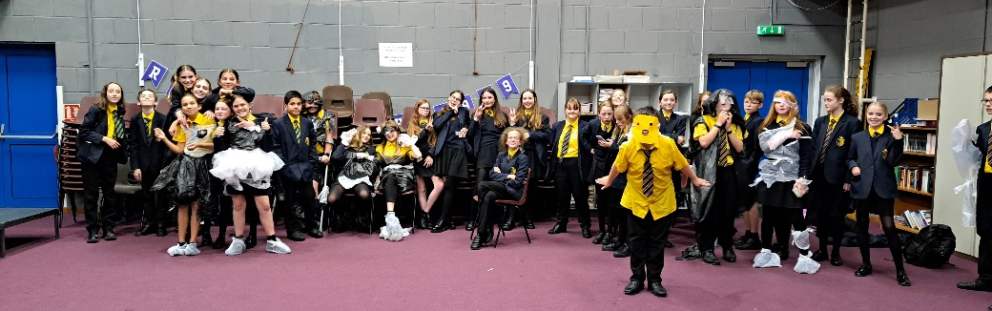

Welcome back!
What an amazing first half-term it’s been!
We’ve had probably our closest race so far with the house cup points as there have been several occasions where just a mere few points have been the difference between House positions. Current standings are currently looking like a Voyager lead…but we’ll see!
We welcomed our amazing Y7s who have been a surge of positivity, kindness and determination! We Heads of House have been meeting with our amazing Y7 tutor groups once a week for a ‘mini assembly’ and house lunch together, which has been such a delightful opportunity to get to know our new members.
Notably, our house events have been back with full force, and we’ve had almost one event for each year group so far! A tense quiz in Music, a costume competition in Drama, Basketball matches, football frenzy and a brand-new Humanities house event. We can’t wait to see you at the next ones! Keep an eye out for posters around the school and in tutor bases for details.
In other news, we’ve had record attendance at some of our clubs, most significantly, Trampolining club! Such fabulous attendance to our extensive range of extra-curricular clubs – ask your tutor for details!
Horizon, Voyager, Endeavour and Pioneer, you make us proud every day! We have a feeling the house rankings will change quite a bit – do keep an eye on the VLE and keep giving your best, every point matters!
Mr Nicholson, Miss Heath, Mr Greenaway and Miss Malone


